Name of the project:

Name of the applicant:

Laboratory/Institute:

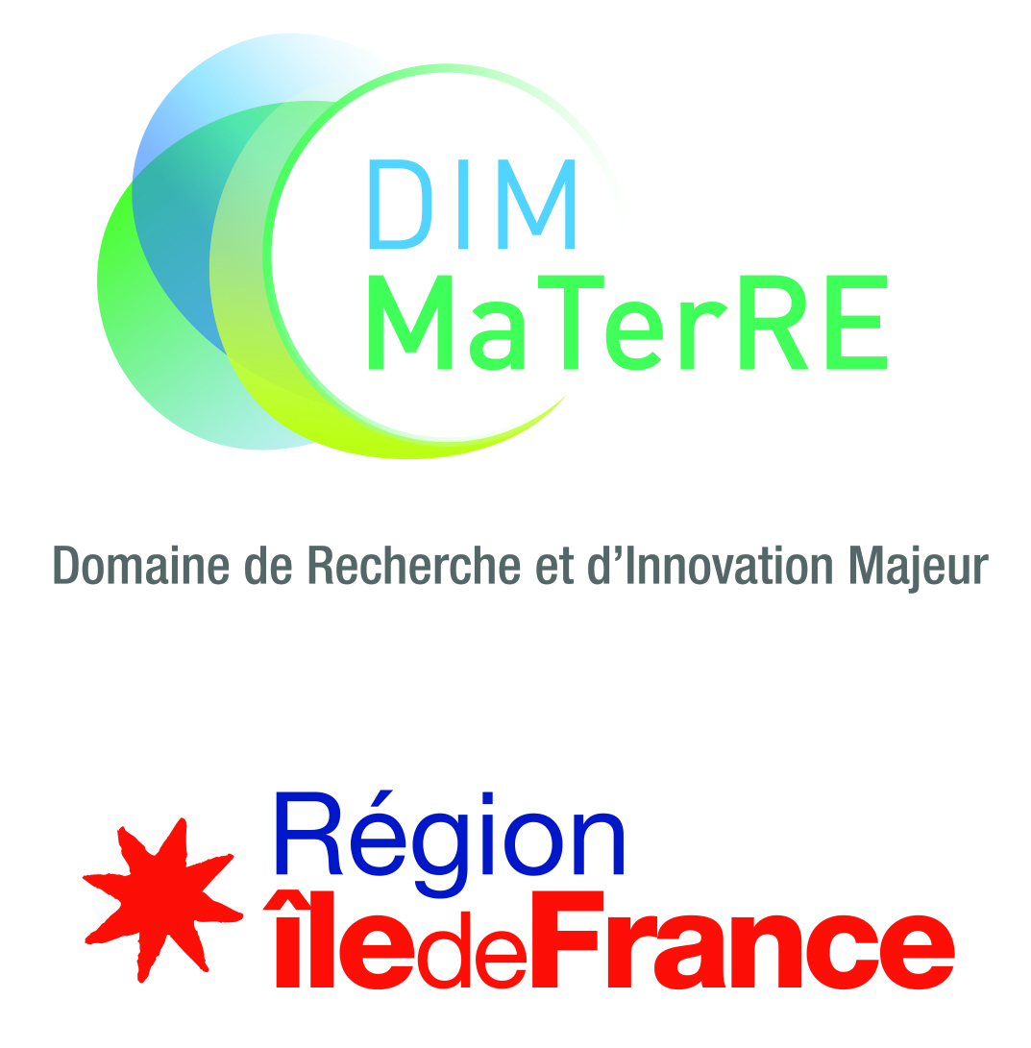
Permanent Call for proposals
Small Equipment

Funding under 50k euros

Files should be submitted on the dedicated platform at the following address: https://materre-2022-3.sciencesconf.org

Contact : dim-materre@espci.psl.eu
ELIGIBILITY
Eligible projects are carried out between team members of MaTerRE (labs working on MaTerRE axes) and the project leader must be from the Ile de France region. Any Ile de France lab is eligible, without prior affiliation to the DIM.
MaTerRE’s contribution can’t exceed 50 000 euros and 60% of the total cost (whichever amount is inferior).
New equipment and/or upgrade of existing ones are eligible as long as it meets the criteria of the call for proposals.
THEMES
Funded projects are supposed to accelerate the development of novel materials that can help overcome the present and future environmental challenges.
The DIM MaTerRE is centered around four thematic axes, corresponding to current scientific, technological and societal challenges:
  - Capture, Valorisation and/or Production of strategic gases (CO₂, H₂…).
  - Eco-compatible Energy Storage or recovery.
- Construction materials.
  - Recycling, eco-design, sustainable materials, urban mining.
This is complemented by 5 transverse methodological axes, including High-throughput methodologies (microfluidics…), Architectured and multiscale Materials, Advanced characterization techniques, numerical methods (databases, artificial intelligence, numerical modelling, simulations…), Economics of the energy transition.
Proposals funded by MaTerRE have to fit within at least one, preferably two, of these axes.
EVALUATION CRITERIA
The evaluation criteria are the following:
  - Scientific and technical quality of the project;
  - Innovative aspect of the project;
  - Quality of the cofinancing plan and quality of the environment of the project;
  - Accessibility for Ile de France researchers and especially MaTerRE members;
  - A federative and structuring effect for the network and Ile de France Region is not compulsory but will be appreciate.

CALENDAR
Projetct can be submitted at any moment during the year on the dedicated platform: https://materre-2022-3.sciencesconf.org
LANGUAGE
Projects must be written exclusively in English
IDENTIFICATION OF THE PARTNERS

 | Lab name, number and address | Team name | Name (first, last) of the project leader | Email | Phone number
Leader
Partner 1
Partner 2
…
Please attach a short resume (max 1 page, including experience, expertise, responsibilities, list up to 5 recent publications, main projects…) of each project leader.

Please highlight what makes the project innovative and, if applicable, federative (maximum 5 lines).

Please highlight the novelty and impact of the proposed project

List up to 5 major publications in the field, not necessarily from your teams (DOI link mandatory)

List of publications

Team members involved in the project

 | First names, Names | Emails
Leader
Partner 1
Partner 2

Thematic or transverse axis or axes concerned

Thematic axes

☐ Strategic gases

☐ Eco-compatible energies
☐ Construction Materials
☐ Recycling, eco-design, sustainable materials and urban mining

Transverse axes

☐ High-throughput

☐ Architected and multiscale Materials

☐ Numerical methods

☐ Advanced characterization

☐ Economics

SCIENTIFIC DESCRIPTION OF THE PROJECT
(3 pages, Times 11)
Title of the project
Key Words
Public summary (for communication purpose)
Join a 300 dpi picture to illustrate the project.
Scientific description of the project; state of the art, innovative character, risks and mitigation plan, expected results
Added value of the equipment for each partner team, if applicable
Partner 1

Partner 2

Structuring effect, if applicable
Access conditions for non-partner teams (MaTerRE and Ile de France teams and labs/ other labs/ Industrial partners)
Use of the equipment after MaTerRE
Adequacy to the objectives and integration to the MaTerRE project
Added value for Ile-de-France Region
Please indicate the expected impacts if the objectives are reached, and the collaborations established in Ile-de-France

Installation and accessibility time frame
Estimated dates of purchase, installation, commissioning etc.

FUNDING SCHEME

Enclose at least one quote (except for internal development)

Host institution in charge of the equipment.

Location of the equipment
Lab
Site

Detailed budget

Category | Amount
 | - €
 | - €
 | - €
 | - €
Total | - €

Envisioned project co-financing.
Please indicate the amount and % of the total cost for each sponsor. If the project is pre-selected, engagement letters or support letter should be presented.
Ile de France Region maximal rate : 60%
Heading | Acquired | Submitted | % of the total | Amount
MaTerRE |  | X | [60% max] | - €
Cofunding 1 : |  |  |  | - €
Cofunding 2 : |  |  |  | - €
 |  |  |  | - €
Total cost |  |  |  | - €

EVALUATION

Suggested experts for peer review (from outside Ile de France, without joint publications with any of the project partners during the past five years)

Unwanted experts (argue)

SIGNATURES

Signature of the project leader

First name, Last name
Position
Place
Date
Signature

Visa / Signature of the laboratory director
First name, Last name
Position
Place
Date
Signature
Signatures are required for the proposals to be accepted.

ANNEX: GENERAL RULES OF THE CALL FOR PROPOSALS MATERRE

Advertency : These rules are likely to be enriched or clarified, on the basis of Region rules, between now and the award of projects.

The objective of MaTerRE is to generate breakthroughs in sustainable materials for the energy transition, both fundamental and applied, by promoting interactions between specialists from different disciplines.
The aim of the call for proposals is to promote innovative, disruptive projects by creating synergies between laboratories.
All the teams working in the fields listed in MaTerRE are eligible to respond to the call for proposals (CFP).
In the case where a team applies for several proposals, MaTerRE requests that the unit director establishes a ranking of the proposals.
The proposals will be selected in a two-stage process:
- Preselection based on the submitted document.
- Selection after audition of the project leader.
The selection of proposals will be organized by MaTerRE's steering committee, supported by a jury including experts from outside the IDF region.

FINANCING
The costs of installation or work, the guarantee - to be provided during the purchase and included in the invoice - are eligible for funding.
The recipient institution agrees to maintain financed equipment.
Any management costs of the beneficiary institutions are not eligible for funding.
The letter of commitment of the co-funder(s) should be presented during the auditions.
Rules for industrial cofounding will be published as soon as possible. Contact us for any question.

ENGAGEMENT OF THE TEAMS

The recipient teams of a grant of the Île de France Region, within the framework of a MaTerRE Call for Proposals, commit to, in particular:
- To read and respect the regional and MaTerRE rules.
- To transfer the progress report (s), the activity report of the project or any other document at the request of the administrative department of the ESPCI, MaTerRE's managing institution, respecting the indicated deadlines and document formats.
- To indicate, in the context of any written publication (article, proceedings ...), the following thank-you text: "This work has been sponsored by the Ile-de-France Region in the framework of MaTerRE”.
- To display, as part of any oral communication (conference, seminar, workshop, school ...) the logo of the Ile-de-France Region and that of MaTerRE and its guardianships.
- To invite a representative the Ile de France Region and of MaTerRE for any inauguration of equipment over 100k€.

See details in annex.

